**Frontend Development with React.js**

**Project Documentation format**

1. **Introduction**
   * **Project Title:** Insight-India
   * **Team Members**:

|  |  |
| --- | --- |
| **Team Members Name** | **Email id** |
| Karthika. P **(Leader)** | Karthika200415@gmail.com |
| Parameshwari. L | vijayalakshmiparameshwari@gmail.com |
| Sahana. S | sahanatharun936@gmail.com |
| Swetha. A | swethaswethaanbu@gmail.com |

.

**2. Project Overview**

**Purpose:**

Insight India is a news aggregation platform that fetches the latest news from various categories, specifically focusing on India. The project aims to provide users with real-time news updates and a search functionality to explore articles on specific topics.

**Features:**

* Displays the latest news from India on the homepage.
* Search functionality to find news articles on specific topics.
* Category-based news browsing (Technology, Politics, Business, etc.).
* Advertisements integrated at the bottom of the homepage.
* Responsive design for an optimal viewing experience.

**3. Architecture**

**Component Structure:**

* **NavbarComponent.jsx**: Navigation bar for category selection and search.
* **Home.jsx**: Main landing page displaying top news.
* **CategoryPage.jsx**: Displays articles filtered by category.
* **HomeArticles.jsx**: Renders individual articles on the homepage.
* **Footer.jsx**: Displays footer content.
* **NewsLetter.jsx**: Subscription section for updates.
* **TopStories.jsx**: Highlights trending news.
* **AdSection.jsx**: Displays advertisements at the bottom of the homepage.

**State Management:**

The application uses the **Context API** for managing global state, ensuring efficient data sharing across components.

**Routing:**

React Router is used to handle page navigation, allowing smooth transitions between categories and the homepage.

**4. Setup Instructions**

**Prerequisites:**

* Node.js installed on your system.
* A valid API key from [NewsAPI.org](https://newsapi.org/).

**Installation:**

1. Clone the repository:
2. git clone https://github.com/your-username/insight-india.git
3. Navigate to the project folder:
4. cd insight-india
5. Install dependencies:
6. npm install
7. Set up environment variables:
   * Create a .env file.
   * Add REACT_APP_NEWS_API_KEY=your_api_key_here.

**5. Folder Structure**

/Insight-india

│── /src

│ ├── /components

│ │ ├── NavbarComponent.jsx

│ │ ├── HomeArticles.jsx

│ │ ├── TopStories.jsx

│ │ ├── Footer.jsx

│ │ ├── NewsLetter.jsx

│ │ ├── AdSection.jsx

│ ├── /pages

│ │ ├── Home.jsx

│ │ ├── CategoryPage.jsx

│ ├── /assets (Images, icons, logos)

│ ├── /styles (CSS files)

│ ├── App.js

│ ├── index.js

│── package.json

**6. Running the Application**

* Start the frontend server:
* npm start
* Open http://localhost:3000 in your browser.

**7. Component Documentation**

**Key Components:**

* **NavbarComponent.jsx**: Handles navigation and search.
* **HomeArticles.jsx**: Displays the latest news articles.
* **CategoryPage.jsx**: Shows news articles based on selected categories.
* **AdSection.jsx**: Renders advertisements.

**Reusable Components:**

* **NewsCard.jsx**: Used to display individual news articles in multiple sections.

**8. State Management**

**Global State:**

* Managed using the **Context API**, which fetches and provides news data across components.

**Local State:**

* Managed within individual components for handling user interactions (e.g., search input).

**9. User Interface**

* The UI consists of a responsive navbar, a dynamically generated news list, and category filters.

**10. Styling**

**CSS Frameworks/Libraries:**

* Styled using CSS modules and global styles.

**Theming:**

* Uses a light theme with a professional news portal look.

**11. Testing**

**Testing Strategy:**

* Unit testing with Jest and React Testing Library.
* Integration tests for API calls.

**Code Coverage:**

* Ensured through Jest’s coverage reports.

**12. Screenshots or Demo**

* **Home page:**

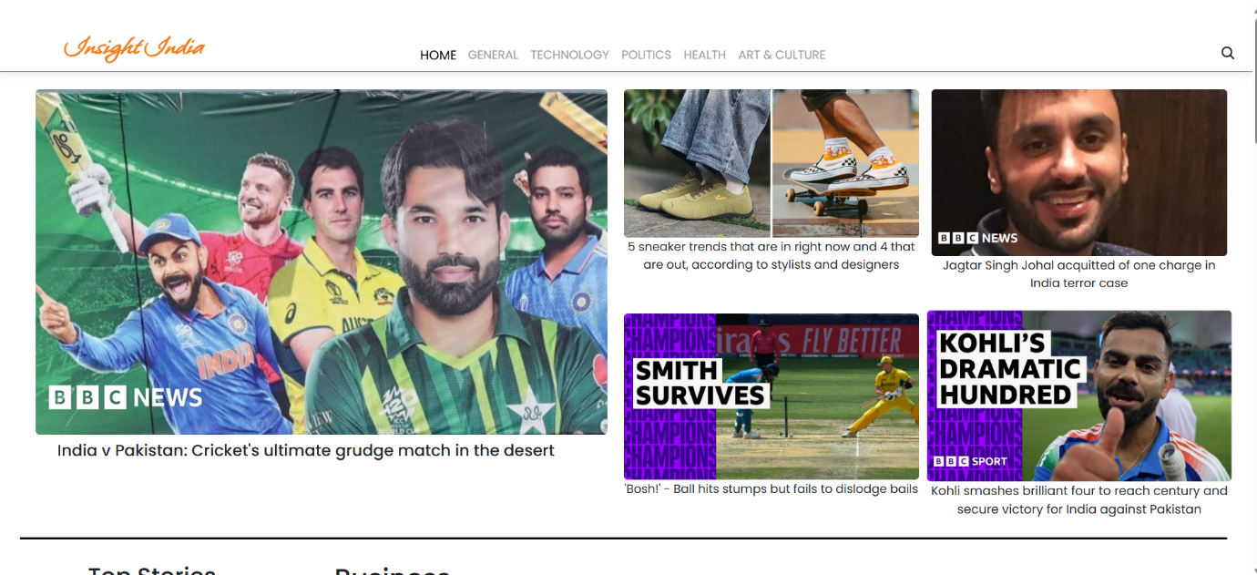

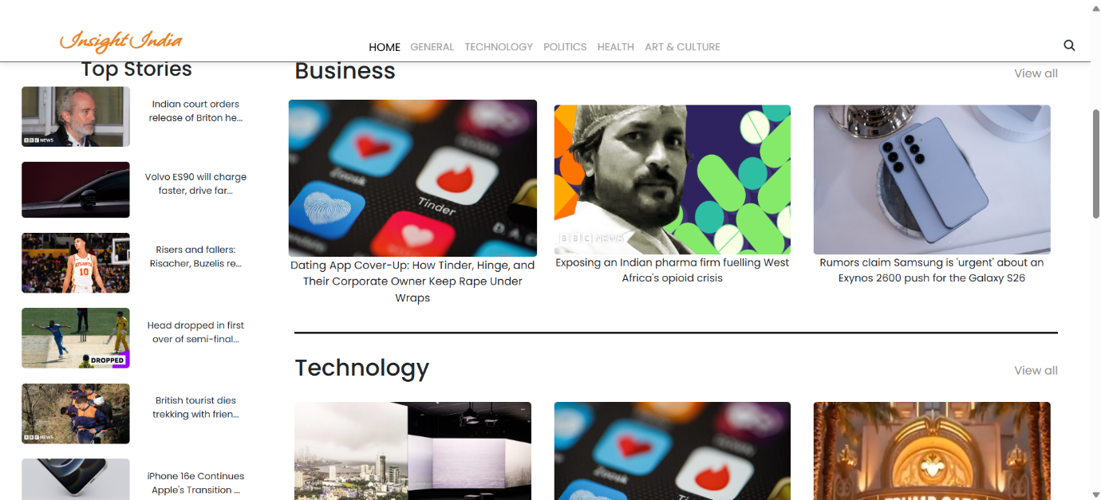

* **Category Wise Pages:**

**General:**

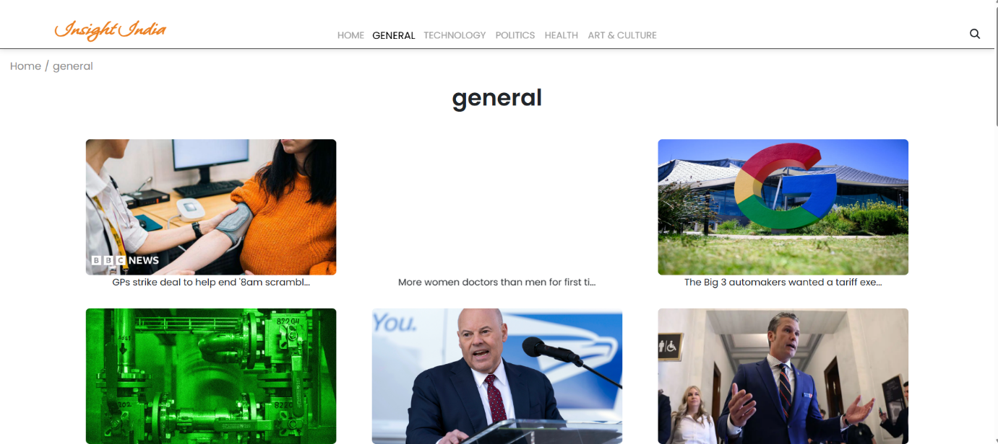

**Art and Culture:**

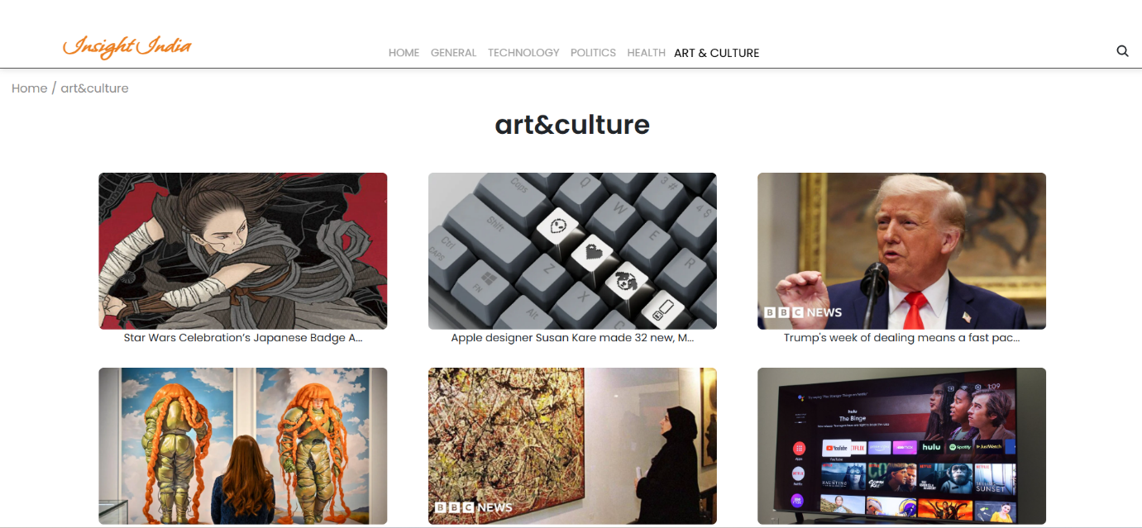

* **Search bar:**

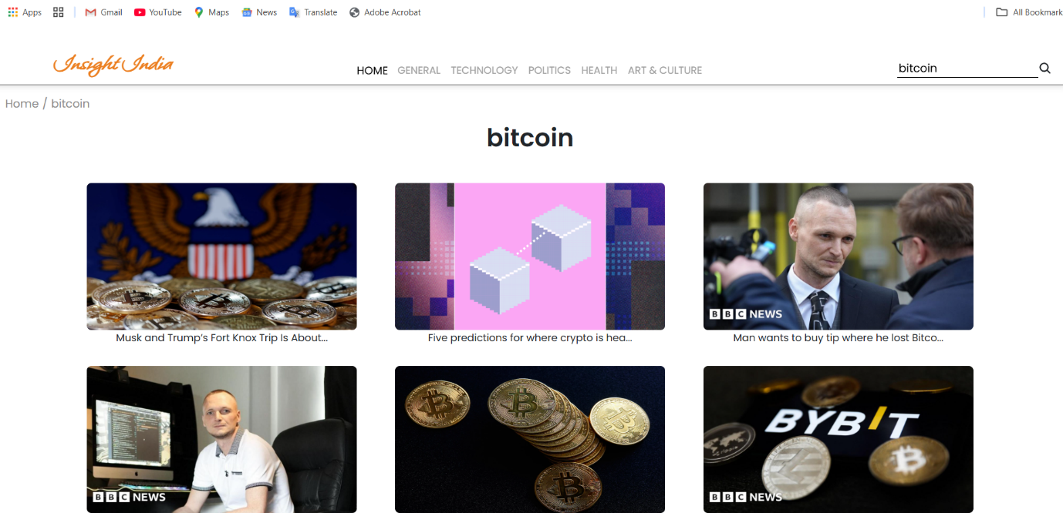

* **Advertisement section:**

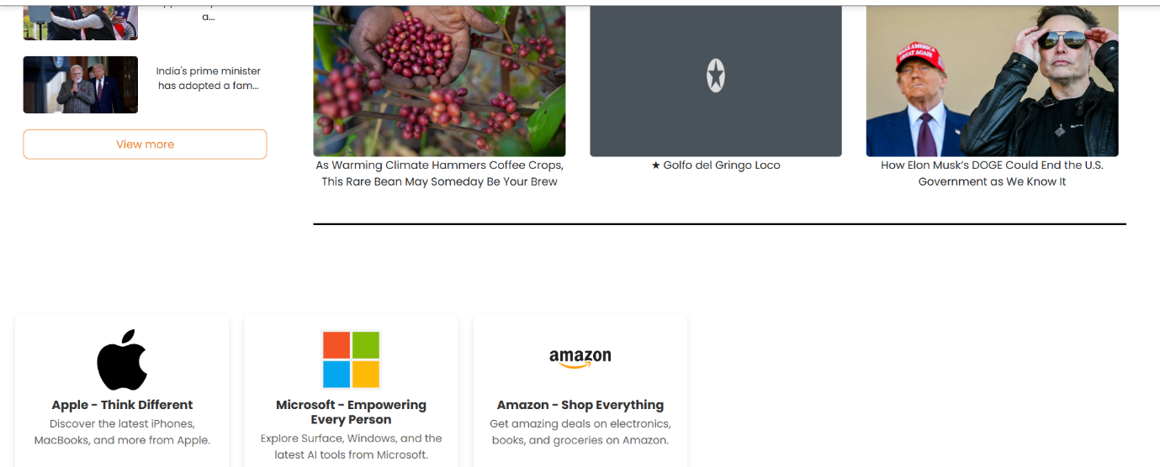

* **Subscription Letter:**

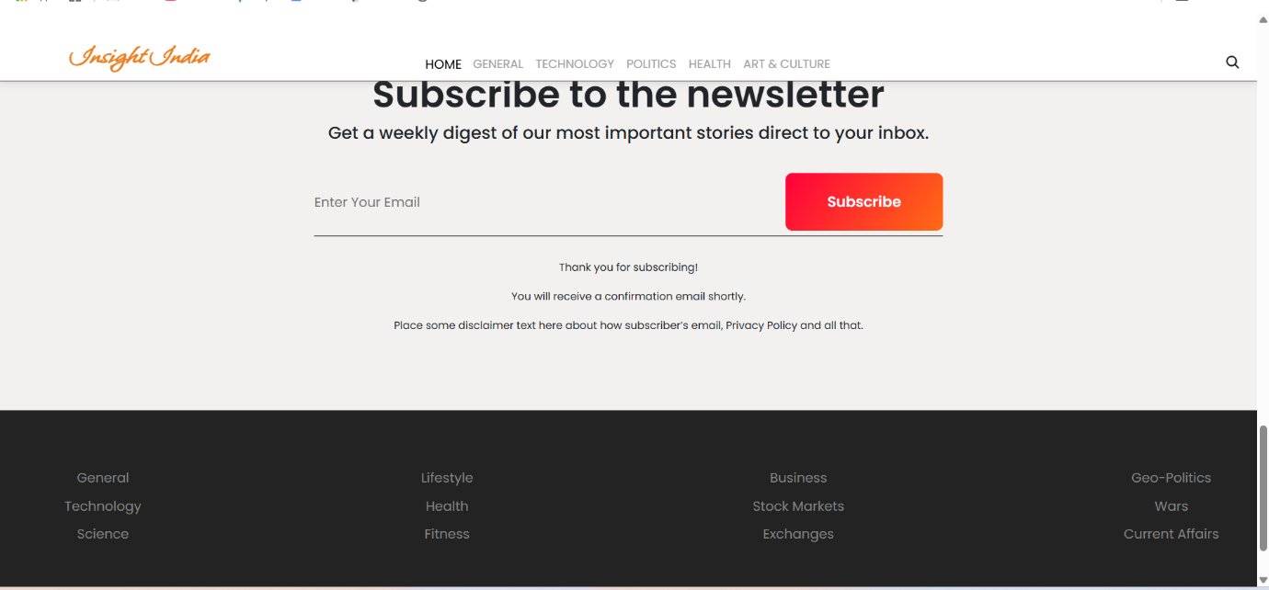

**13. Known Issues**

* API request limits may cause intermittent failures.
* Some categories might not fetch results if NewsAPI restrictions apply.

**14. Future Enhancements**

* Implement user authentication for personalized news.
* Add dark mode and customizable themes.
* Improve search filtering with AI-based recommendations.